Applied Discrete Modelling

Kanishk Kashayap, XxX Himanshoo, Atif Usman

Assignment- 4

**System Specification**

The quality tester’s behavior is described by the above SPN. (time unit = 1 s)

Assume that the probability for the item to test OK is 0.9 for source 0 and 0.95 for source 1.

**Implementation**

Modify the given hard-coded Proxel-program to simulate the above Petri net.

**Tasks and Questions**

Construct the state space and RG of the above model.

Use your program to answer the following questions:

* How many parts are tested on average within one hour for different time steps (e.g. 20, 10, 5, 2)?
* How many parts from source 0 (and source 1) have been tested defective for different time steps (e.g. 20, 10, 5, 2)?

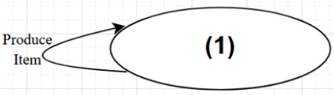

**Reachability Graph**

**Task 01:** How many parts are tested on average within one hour for different time steps (e.g. 20, 10, 5, 2)?

Sol:

|  |  |
| --- | --- |
| Time-Step | Number of Parts Tested |
| 20 | 359 |
| 10 | 716 |
| 5 | 880 |
| 2 | 1870 |

**Task 02:** How many parts from source 0 (and source 1) have been tested defective for different time steps (e.g. 20, 10, 5, 2)?

Sol:

|  |  |  |
| --- | --- | --- |
| Time-Step | Average Defective Parts Tested | |
|  | **Source 0** | **Source 1** |
| 20 | 26.9 | 4.5 |
| 10 | 53.8 | 8.9 |
| 5 | 72.0 | 8.0 |
| 2 | 180.0 | 3.5 |